I pledge on my honor that I have not given or received any unauthorized assistance on this

assignment/examination. I further pledge that I have not copied any material from a book, article,

the Internet or any other source except where I have expressly cited the source.

Signature: Kanika Yadav

Date: 11/10/2022

Topic name – Chap 16. Multi-criterion Decision Making

Name - Kanika Yadav

Date: November 10, 2022

W&A Chapter - 16

Question No – Q16 & Q 25

Page no – 16-10 & 16-31

**Management Overview**

**Problem Statement:**

W&A 4E **Chapter16 = 3E Chapter 9**

4Edition Q2 **or** 3Edition Q2

1. Gotham City must determine how to allocate ambulances during the next year. It costs $5000 per year to run an ambulance. Each ambulance must be assigned to one of two districts.   
   Let xi be the number of ambulances assigned to district i, i = 1, 2.   
   The average time (in minutes) it takes for an ambulance to respond to a call from district 1 is 40 - 3x1; for district 2, the time is 50 - 4x2. Gotham City has three goals (listed in order of priority):
   * Goal 1: At most $100,000 per year should be spent on ambulance service.
   * Goal 2: Average response time in district 1 should be at most five minutes.
   * Goal 3: Average response time in district 2 should be at most five minutes.
   * Use goal programming to determine how many ambulances to assign to each district.
   * How does your answer change if goal 2 has the highest priority, then goal 3, and then goal 1?

**Data Sources:** above problem statement

**Model Approach:** **Goal Programming**

**Solution & Sensitivity Analysis:**

The variables and constraints for Gotham city model are shown in the sheet.   
The time is calculabted basedon the variable defined to be the changing variables, Here we try to minimiza the overall cost of the Ambulance in Distrct I 1 and district 2 andn it is under the constraint of below $5000 initially. And we ensure that the problem solution satifies all the goals defined by the Gotham city for its ambulance networks simultaneously.

For Goal based solutions as we can see following are the results –

1. To fit into the first goal which can be considered as hard constraint and the others as soft constraint we can determine that the maximum benefits that can be achieved with Linear Programming model with no objective. We are given a budget hard constraint with Goal 1 as $100,000 which is not to be violated no matter what. Which results in the best possible solution as – As clear it is from the following results the Goal 1 follows above the goal since it has calculated the budget amount of $100,000. In goal programming model the soft constraints are prioritized

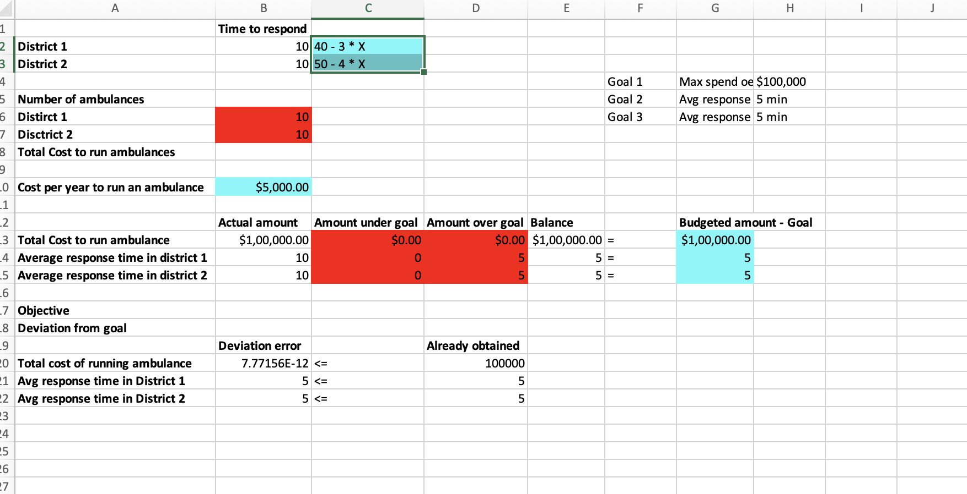

1. For problem 2 there is a requirement of time limit of 5 mins to each district and hence the values can be considered as hard constraint whereas the goal 1 will be a Soft constraint that leads to the solution of to see how these fit into the goal programming methodology. You get there one step at a time. We use the same setup as before and calculate the amount under goal or over goal.

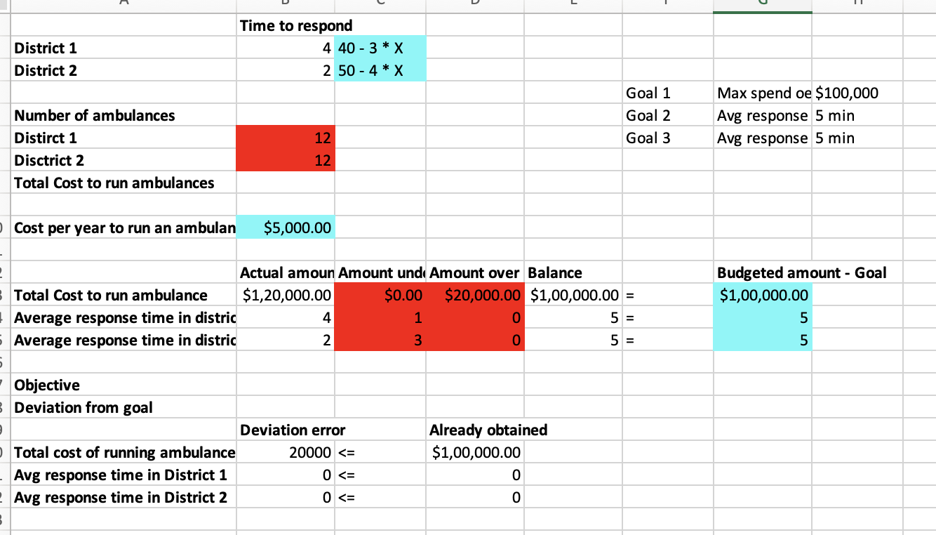

**Management Overview**

**Problem Statement:** 4Edition Q25 **or** 3Edition Q25

Each professor’s annual salary increase is determined by his or her performance in three areas: teaching, research, and service to the university. The administration has assessed the pairwise comparison matrix for these objectives as shown in the file P16_25.xlsx. The administration has compared two professors with regard to their teaching, research, and service over the past year. The pairwise comparison matrices are also shown in this file.

1. Which professor should receive a bigger raise?
2. Does AHP indicate how large a raise each professor should be given?
3. Check the pairwise comparison matrix for consistency.

**Data Sources:** P16_25.xlsx

**Model Approach: AHP Multiple Choice**

**Solution & Sensitivity Analysis:**

1. Which professor should receive a bigger raise?

As per the results in the AHP multiple choice programming and evaluation it is clearly observed that Professor 2 should receibe a bigger raise. Because the weighted acroe based on his teaching, research and service has the best impact on the impact as compared to the other professor who has scored 0.45.   
Hence Professor 2 stands at higher advantage on achieving a weighted score of 0.63

1. Does AHP indicate how large a raise each professor should be given?

No the AHP does not indicate how large a raise should be given since the matrics of calucation are based on the individual professors teaching research and service skills

1. Check the pairwise comparison matrix for consistency.

On **calculating consistency index with the pairwise comparison matrix, the CI stands at - 0.032756**

**Whereas CI/RI ratio stands at - 0.056476 which is higher than expected 0.01 or below.**

